CROFTON NEWS – March 2024

VIEW FROM THE GOVERNING BODY

First of all, on behalf of the governing body, I would like to welcome Miss Coggill to Crofton Junior School. I am aware that she has made a very positive start as Spotted Owls class teacher for the remainder of the academic year.

I would also like to congratulate Miss Peel who is due to have her first child in August. Even though she has only been at Crofton Junior School for a short period of time, she has made a very positive impact as Snowy Owls class teacher. I would like to thank her for all her hard work and dedication and wish her every success in the future when she leaves us at the end of the academic year.

Another member of staff, who is leaving us at Easter, is Mrs Delamere. Mrs Delamere joined school in November 2011 and has therefore cared for and supported many children in her role as lunch time supervisor. She has always been a very popular member of staff and we wish her a very enjoyable retirement.

Losing valued members of staff is always difficult; however, it does provide the opportunity for new people to join school and share their experience and enthusiasm. As a governing body, we are working closely with Mr Birdsall in order to ensure that we employ high quality candidates to replace them.

Finally, I am aware that Mr Birdsall has informed you that he also will be leaving school to join Snapethorpe Primary School at the end of the academic year. A change of leadership is always a pivotal time in any organisation, whether it is a business or a school. I can assure you that we as a governing body are working closely with the Local Authority to employ a high-quality candidate, who will work alongside a very strong senior leadership and staff team, in order to continue to provide the outstanding quality of education that all the pupils deserve.

Yours faithfully,

Mrs S. Borman
Chair of Governors

SCHOOL READATHON

Our CJS Readathon has now been running since 17th January and will be soon coming to an end on World Book Day, Thursday 7th March. Please can we remind parents to note the children’s minutes that they have read at home each week on their individual log sheet. Children are hopefully busy reading at home to meet their 500 minutes in 50 days challenge! They have also been busy at school and all children- and adults- enjoyed our ‘drop everything and read’ session on Friday 9th February.

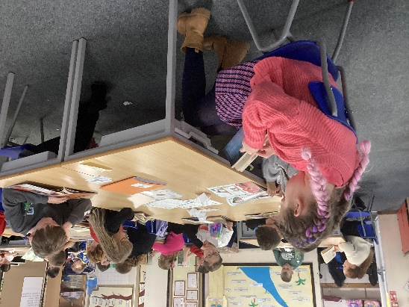
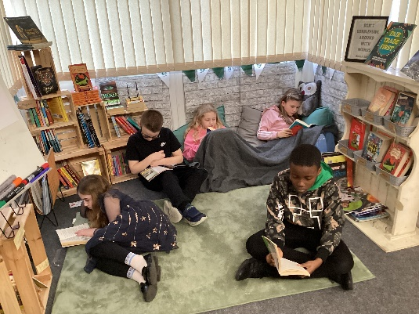

After World Book Day, we will start to collect in sponsor money. We would like to thank everyone in advance for their continued support in raising funds for school and promoting a love of reading.

PARENTS’ EVENING

We will be holding our next parents’ evening on Tuesday 16th & Wednesday 17th April. These dates will provide the opportunity for all parents/carers in Years 3, 4 & 5 to meet with their child’s class teacher to discuss their progress and attainment and how we can work together to best support them in their development. Only parents/carers of those children who are working just below their full potential in Year 6 will be invited, as they completed a full parents’ evening in January. Please look out for further information regarding when and how to book an appointment.

ROBINWOOD RESIDENTIAL

I would like to thank all the parents/carers for supporting our Year 5 Robinwood residential this year. As always, it provides the children with such a wonderful experience. It was a pleasure to see their confidence grow over the three days as well as their ability to communicate, cooperate and work together effectively. We are already in the process of booking for next year so our current Year 4 pupils can have the same opportunity.
SCHOOL MEAL FAVOURITES DAY

Following the success of our school meal favourites day last half term, we have organised for it to take place once again on Thursday 14th March. The menu will consist of:
- Cheese pizza
- All day breakfast
- Sandwich/wraps or jacket potato with a variety of fillings
- Warm chocolate brownie and ice cream

As always, all children are able to choose to have a school dinner every day or just on individual days.

ATTENDANCE

The overall school attendance at February half term, which is the half way point of the school year, was 95.77%, which remains in the ‘Green – Good Attendance’ category and is close to our 96% target.

Outstanding attendance  Blue: 98%-100% | The best chance of success.
Good attendance
Green: 95% – 97.9%

Worrying attendance  Amber: 90% - 94.9% | Less chance of success because of periods of lost learning time.  Makes it harder to progress well.
Serious Concerns attendance Red: below 90% about | Significant lost learning time.

Individual class attendance currently is:

- Elf Owls – 96.85%
- Snowy Owls – 96.12%
- Sooty Owls – 93.51%
- Spotted Owls – 95.27%
- Barn Owls – 95.96%
- Tawny Owls – 97.14%
- Eagle Owls – 95.52%
- Hawk Owls – 95.78%

Elf, Snowy & Spotted Owl classes have earned the most money (£50) so far towards an end of year treat of their choosing. Each week, the class with the highest attendance is awarded £5.

We currently have 29 pupils (12%) whose attendance is below 90%, and are therefore classed as being persistently absent. There are significant concerns about lost learning time for these children.

The number of persistently absent pupils appears to be remaining quite constant and applies to the same pupils. The most common reasons for pupil absence are illness, lateness between 8:45-9:00am, term time holidays and lateness after 9:00am. In order to begin to reduce this, I would urge all parents and carers to make sure that their child is in school by 8:40am at the latest so that they can line up with their class mates before going into class. This allows the children to have the best possible start to the school day and maximise their learning.

DIARY DATES

- Pre-loved Book Day – Thursday 7th March
- Elf Owls visit to This Green Moon – Wednesday 13th March
- Year 4 Egyptians’ Museum Parents’ Presentation – 2:30pm Wednesday 13th March (homework projects to be brought into school on Tuesday 12th)
- Scientist Dress Up and Poster Day – Thursday 14th March
- School Meal Favourites Day – Thursday 14th March
- Snowy Owls visit to This Green Moon – Friday 15th March
- Year 6 residential to France – Sunday 17th – Friday 22nd March
- Break up for Easter – Friday 22nd March
- Return to school – Monday 8th April
- Parents’ Evening – Tuesday 16th & Wednesday 17th April
- May Day – Monday 6th May
- Year 6 SATs Week – Monday 13th – Thursday 16th May
- Children break up for half term – Friday 24th May
- Return to school – Monday 3rd June
- Year 4 Multiplication Times Table Check Week - 3rd-7th June
- Art Week – 10th-14th June
- Years 3 & 4 visit to the Yorkshire Sculpture Park – Monday 10th June
- Years 5 & 6 visit to the Yorkshire Sculpture Park – Tuesday 11th June
- Next Step Transition Workshop at Crofton Junior School for Year 6 Parents - 5:00-6:30pm Wednesday 12th June
- Parents’ Art Week Showcase – 2:45pm Friday 14th June
- Year 5 visit to Jamia Masjid Swafia Mosque – Tuesday 18th June
- Inset Days Friday 21st June & Monday 24th June
- Year 5 visit to Murton Park – Thursday 11th July
- Children break up for the summer – Friday 19th July
- Inset Day Monday 22nd July

Yours faithfully,

Mr P. Birdsall
Headteacher & Designated Safeguarding Lead

